Coffee Market Analysis

Business Intelligence Case Study

Prepared for:
ACME Baristas

Prepared by:
Vamsikrishna Manne

1. Executive Summary
ACME Baristas is planning to expand its business by launching coffee retail operations in three international markets. To support this strategic decision, an end-to-end Business Intelligence solution was developed to analyze historical global coffee market data using Python, PostgreSQL, SQL, and Streamlit.
The analysis integrates coffee production, domestic consumption, imports, exports, inventory levels, and population data to identify attractive expansion opportunities. An ETL pipeline was built to extract, clean, transform, validate, and load the data into a PostgreSQL data warehouse. SQL analytical queries and interactive dashboards were then developed to generate business insights.
The findings indicate that the global coffee market has experienced sustained long-term growth in both production and consumption, supported by strong international trade. Although coffee production is concentrated in a relatively small number of countries, many consumer markets rely heavily on imports to satisfy domestic demand, creating attractive opportunities for coffee retailers.
Based on the analysis, the United States, Japan, and Canada are recommended as the most suitable markets for ACME Baristas' expansion. These markets combine high coffee consumption, significant import dependency, and large potential customer bases, making them attractive destinations for a new coffee retail chain.
While the overall market outlook is positive, the analysis also identifies potential risks including strong competition from established coffee brands, fluctuations in coffee commodity prices, supply chain disruptions, and regional differences in consumer preferences. These risks can be mitigated through strategic sourcing, localized product offerings, and diversified supply chain partnerships.
Overall, the analysis supports ACME Baristas' international expansion strategy and demonstrates how data-driven decision-making can be used to identify promising markets and inform long-term business planning.

2. Business Objective
ACME Baristas plans to expand its business by launching coffee retail operations in three international markets. Selecting suitable markets for expansion requires a thorough understanding of global coffee demand, production capacity, trade patterns, and consumer behavior.
The objective of this analysis is to evaluate historical coffee market data and identify the most attractive markets for expansion using a data-driven approach. The analysis focuses on coffee production, domestic consumption, imports, exports, inventory levels, and population data to assess market potential and support strategic decision-making.
To achieve this objective, an end-to-end Business Intelligence solution was developed, including data extraction, transformation, validation, warehouse design, SQL analytics, and interactive dashboards. The resulting insights help identify high-potential markets, evaluate whether current market conditions support expansion, and highlight key opportunities and risks that ACME Baristas should consider before entering new international markets.

3. Data Sources
The analysis is based on two publicly available datasets that provide complementary information about the global coffee market and country populations. These datasets were integrated during the ETL process to create a unified analytical data warehouse.

3.1 International Coffee Organization (ICO) Dataset
The primary dataset contains historical coffee market information for coffee-producing and consuming countries. It includes annual observations covering several decades and provides key business metrics such as:
- Coffee production
- Domestic consumption
- Coffee exports
- Coffee imports
- Beginning and ending stock levels
- Arabica and Robusta production
- Market year information
This dataset forms the foundation for analyzing global coffee production, trade patterns, and market trends.

3.2 World Bank Population Dataset
The second dataset was obtained from the World Bank and provides annual population estimates for countries worldwide.
The population data was integrated with the coffee market dataset to:
- Calculate per-capita coffee consumption
- Compare market size across countries
- Evaluate potential customer bases
- Support country-level business analysis

3.3 Country Reference Dataset
A country reference dataset containing standardized country names and ISO country codes was used to harmonize country information across multiple data sources.
This dataset enabled:
- Standardization of country names
- Mapping of ISO2 and ISO3 country codes
- Improved data consistency
- Accurate joins between datasets

Data Integration
The three datasets were integrated through a standardized country dimension during the ETL process. Country names were harmonized, validated, and mapped using ISO codes to ensure consistent reporting across the PostgreSQL data warehouse.
The integrated dataset provides a reliable foundation for SQL-based business analysis and interactive dashboard visualizations.

Dataset | Purpose | Key Attributes
International Coffee Organization (ICO) | Coffee market analysis | Production, Consumption, Imports, Exports, Stocks
World Bank Population | Market size analysis | Population by Country and Year
Country Reference Dataset | Data harmonization | Country Names, ISO2, ISO3, ONU Codes

4. Methodology
To answer ACME Baristas' business questions, a structured Business Intelligence workflow was developed. The methodology consisted of five major stages: data extraction, transformation, validation, warehouse development, and business analytics. This approach ensured that the analysis was based on accurate, consistent, and well-organized data.

4.1 Data Extraction
The first stage involved collecting data from three independent datasets:
- International Coffee Organization (ICO) coffee market dataset
- World Bank population dataset
- Country reference dataset containing ISO country codes
These datasets were imported into Python using the Pandas library and served as the foundation for the ETL pipeline.

4.2 Data Transformation
The raw datasets contained differences in country names, formats, and structures. Several transformation steps were performed to prepare the data for analysis.
The transformation process included:
- Standardizing country names across datasets
- Harmonizing country information using ISO country codes
- Cleaning inconsistent values and column names
- Converting the population dataset from wide format to long format
- Aggregating coffee attributes into analytical fact tables
- Calculating per-capita coffee consumption using population data
These transformations produced clean and consistent datasets suitable for loading into the PostgreSQL warehouse.

4.3 Data Validation
To improve data quality, multiple validation checks were incorporated into the ETL pipeline.
The validation process included:
- Missing value analysis
- Duplicate record detection
- Country name consistency checks
- Fact table validation
- Warehouse validation
- Referential integrity validation between fact and dimension tables
These validation steps ensured that the analytical data warehouse contained accurate and reliable information before business analysis was performed.

4.4 PostgreSQL Data Warehouse
A dimensional data warehouse was designed to support analytical queries.
The warehouse consists of:

Dimension Table
dim_country
Stores standardized country information, including:
- Country ID
- Country Name
- ISO2 Code
- ISO3 Code
- ONU Code

Fact Tables
fact_coffee
Contains annual coffee market metrics such as:
- Production
- Consumption
- Imports
- Exports
- Beginning Stock
- Ending Stock
fact_population
Contains:
- Population
- Country
- Year
This star-schema design improves query performance and simplifies analytical reporting.

4.5 SQL Business Analysis
After loading the warehouse, analytical SQL queries were developed to answer key business questions.
The SQL analysis included:
- Global market KPIs
- Top producing countries
- Top consuming countries
- Top exporting countries
- Top importing countries
- Production surplus and deficit analysis
- Import dependency analysis
- Per-capita coffee consumption
- Historical trend analysis
- Country-level market comparisons
These analyses provided quantitative evidence for market selection and strategic recommendations.

4.6 Interactive Dashboard
An interactive dashboard was developed using Streamlit and Plotly to visualize the analytical results.
The dashboard includes five sections:
- Executive Overview
- Market Intelligence
- Country Explorer
- Trend Analysis
- Business Recommendations
The dashboard allows users to explore historical trends, compare countries, and interactively analyze coffee market indicators.

4.7 Methodology Workflow
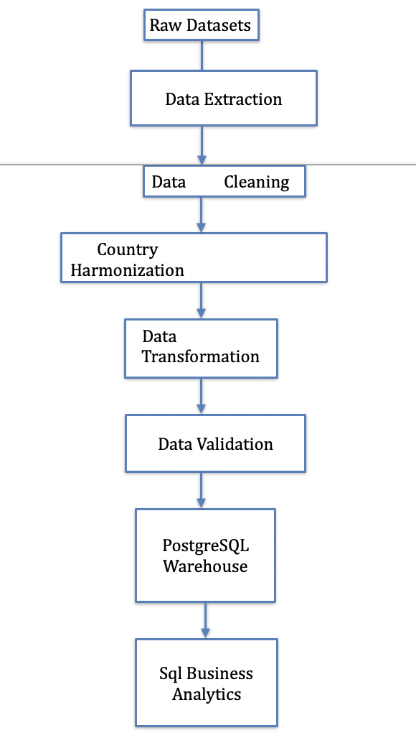

5. Business Questions

5.1 Recommended Markets

5.1 Recommended Markets
The selection of target markets was based on multiple analytical indicators rather than a single metric. The analysis considered coffee consumption, import volumes, production deficits, import dependency, population size, and per-capita coffee consumption to identify markets with strong customer potential.
The recommended markets are presented below.

Rank | Country | Why
1 | United States | High consumption, high imports, large production deficit, large customer base
2 | Japan | High consumption, strong import dependency, mature coffee market
3 | Canada | High per-capita consumption, high imports, established coffee culture

5.2 Is this a good time to enter?
Yes.
The historical data indicates sustained long-term growth in both coffee production and domestic consumption. Although yearly fluctuations are present, the overall trend suggests that global demand for coffee has remained strong over the study period.
Trade analysis further demonstrates that international imports and exports continue to play an important role in balancing global supply and demand. These findings indicate a mature and stable market that supports new retail expansion opportunities.

Supporting Evidence
- Production trends show long-term growth.
- Consumption trends generally increase over time.
- The international coffee trade remains active.
- Global coffee demand continues to be supported through imports and exports.
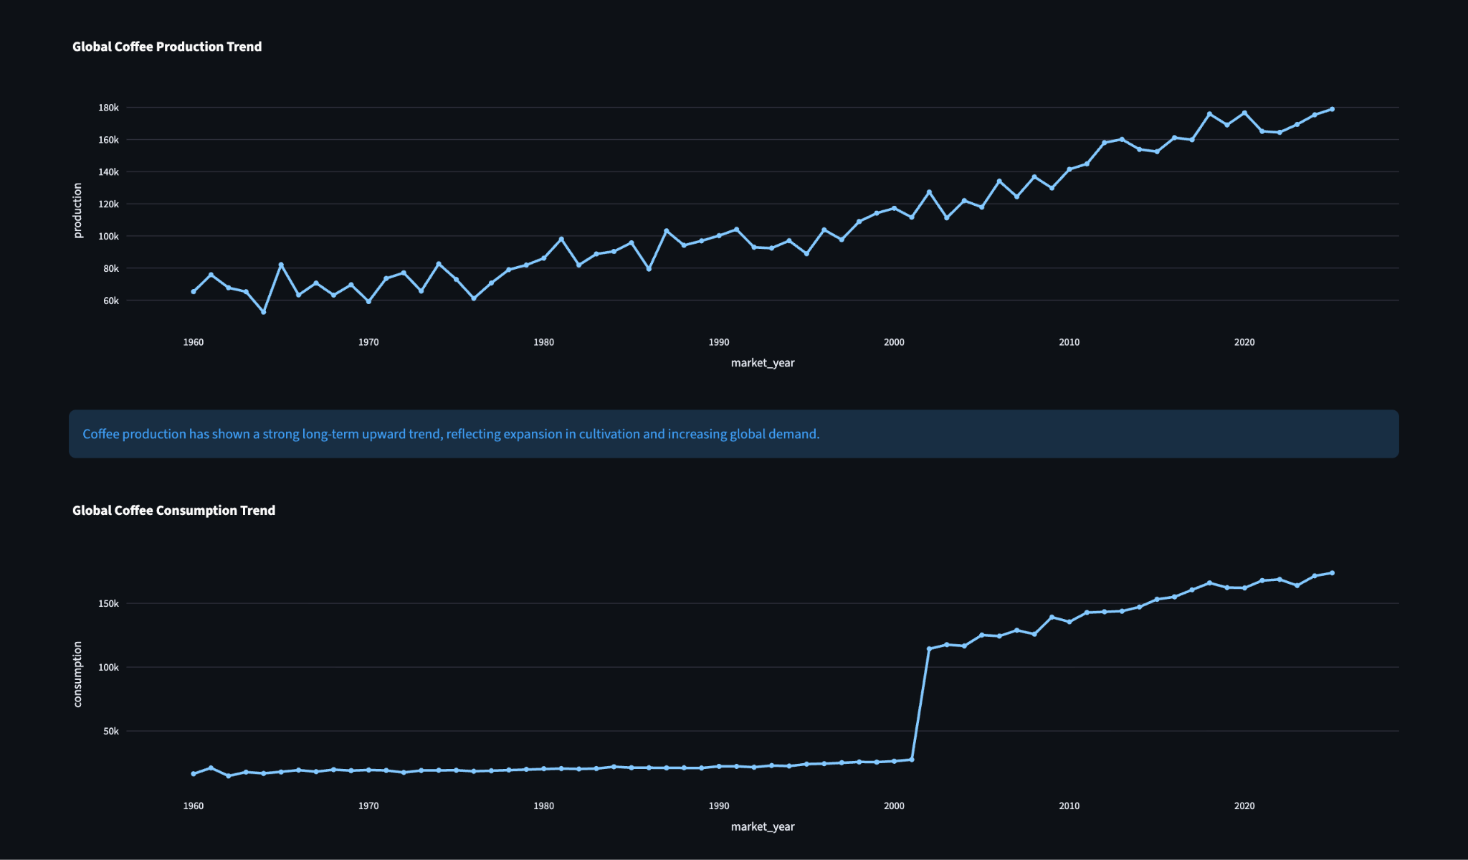

5.3 Opportunities
The analysis identified several opportunities for ACME Baristas:
- Large consumer markets with established coffee demand.
- Import-dependent countries require reliable coffee supply.
- High per-capita consumption indicating mature coffee-drinking cultures.
- Reliable sourcing opportunities from major producing countries such as Brazil and Vietnam.

5.4 Risks
The analysis also highlights several risks that should be considered:
- Strong competition from established international coffee brands.
- Dependence on global supply chains for imported coffee.
- Commodity price fluctuations affecting operating costs.
- Differences in consumer preferences across countries requiring localized product offerings.

6. Key Business Insights
The analysis identified several important patterns in the global coffee market that support strategic decision-making for ACME Baristas.
- Coffee production is concentrated in a relatively small number of producing countries, with Brazil and Vietnam contributing a significant share of global production.
- Coffee consumption has generally increased over the historical period, indicating sustained global demand.
- Many large consumer markets depend heavily on imported coffee rather than domestic production.
- Countries with high import dependency represent attractive opportunities for coffee retailers due to established consumer demand.
- Per-capita consumption analysis highlights mature coffee markets where coffee is embedded in daily consumer habits.
- International trade plays a critical role in balancing global coffee supply and demand.
- Historical market trends suggest that coffee remains a stable global commodity with long-term growth potential.

